**Course: Advance Bio Informatics**

**Module Title: Information Extraction**

**Module No: 94**

**Information Extraction**

* Extracting information from m/c readable documents.
* Processing human language texts by means of NLP methods.
* Text/Images/audio/video.

Towards structure data Merger (c1, c2, date). Logical reasoning to draw inferences. DOB(1980).Text simplification.

**BioNLP**

Text mining applied to texts and literature of the biomedical and molecular biology domain.

**Information Extraction**

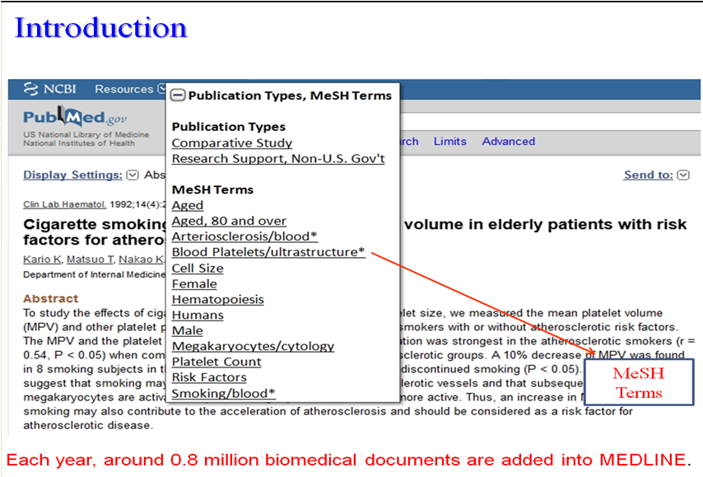

**Motivation**

* PubMed
* Classification
* Retrieval
* Summarization